Ahmed Kasteer

7-C  20F-0336

XSS + SQL Injection Lab

**XSS LAB**

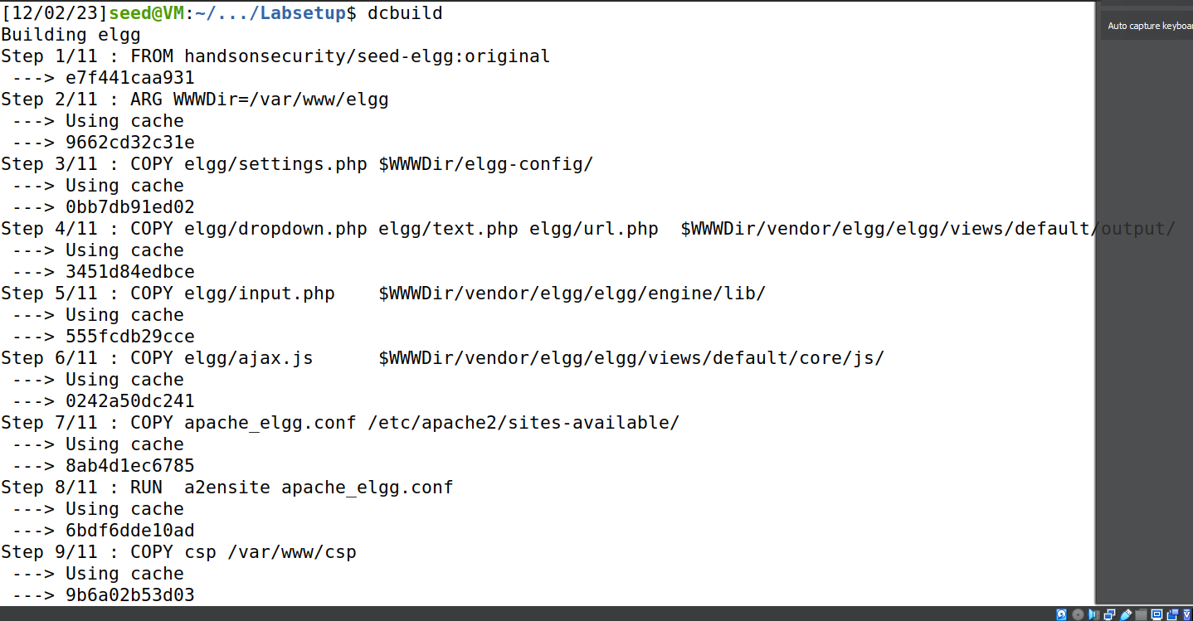

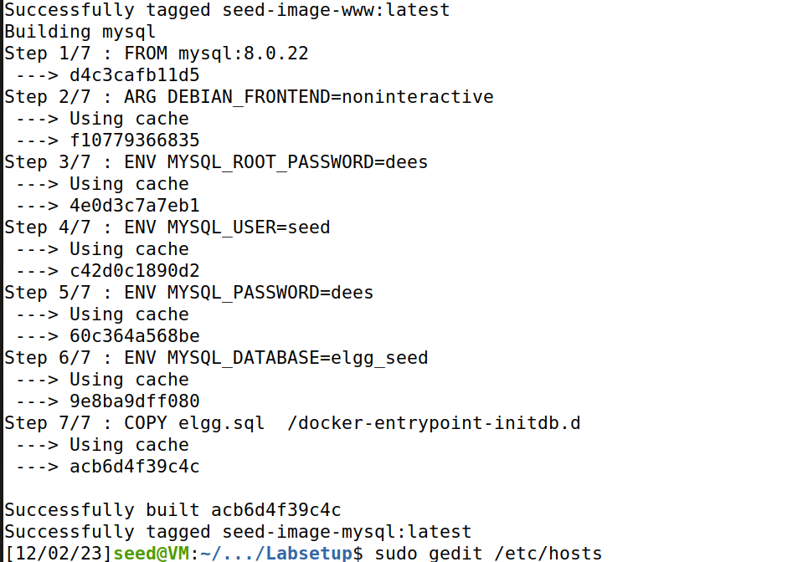

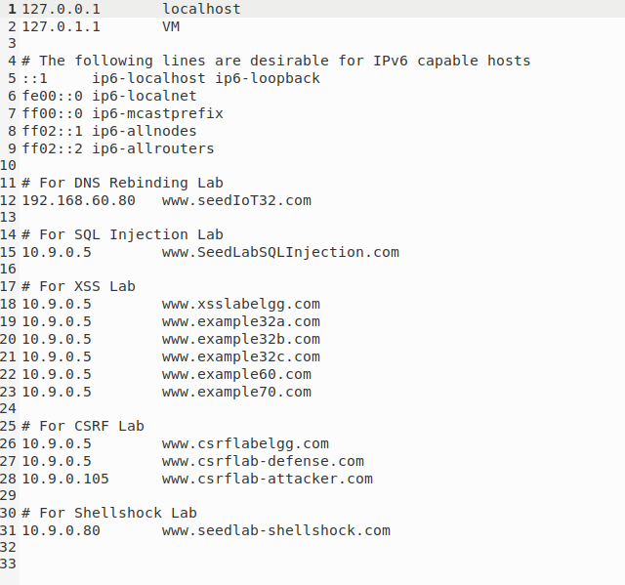

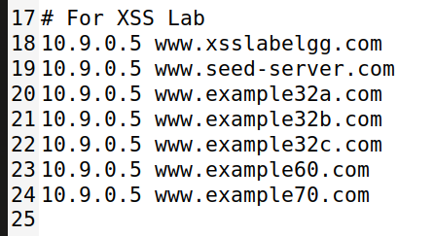

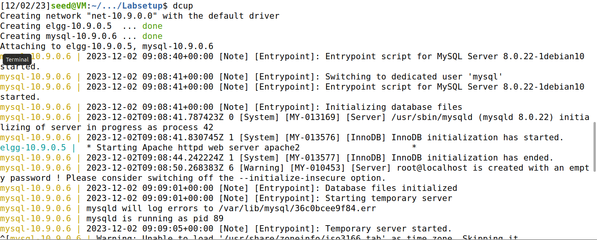

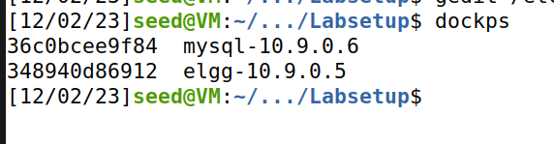



**TASK 1**

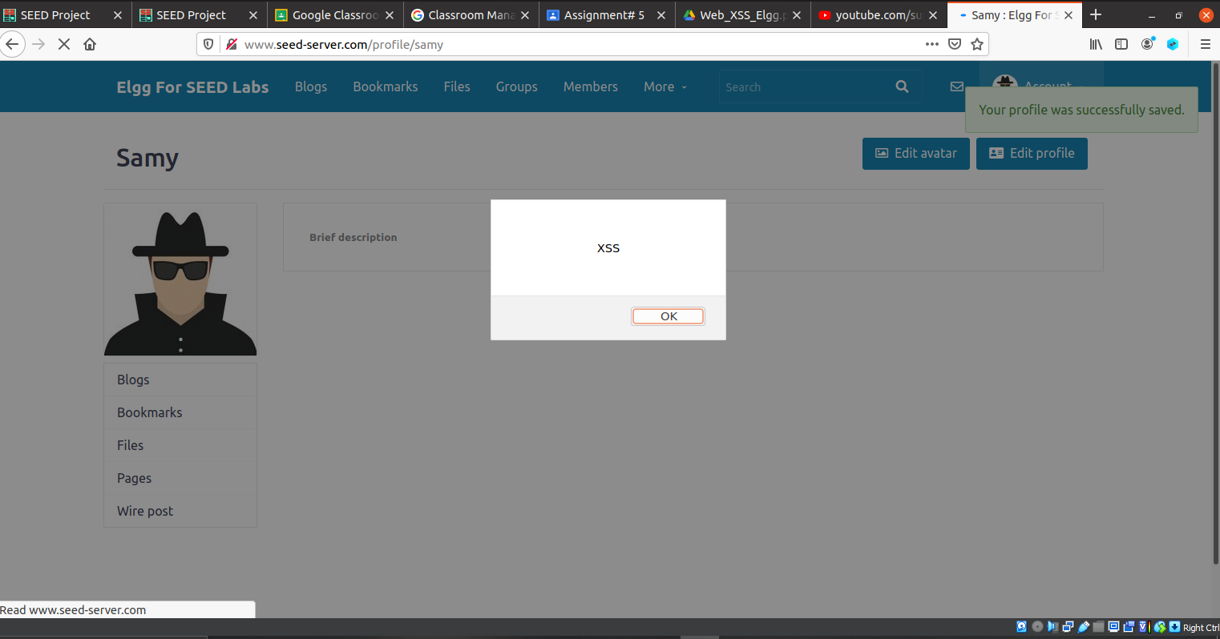

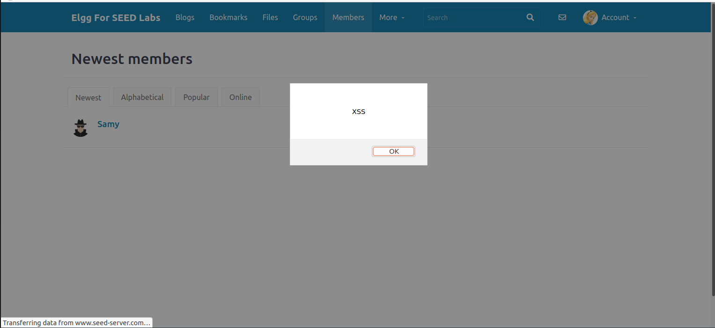

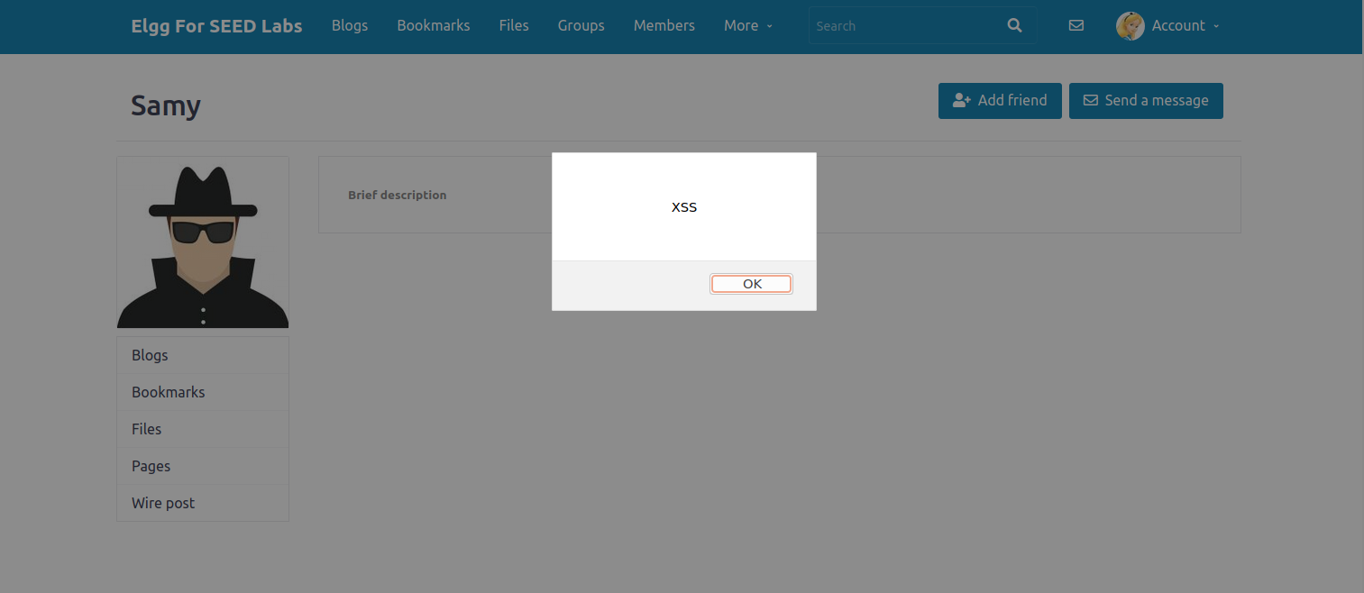

**TASK 2**

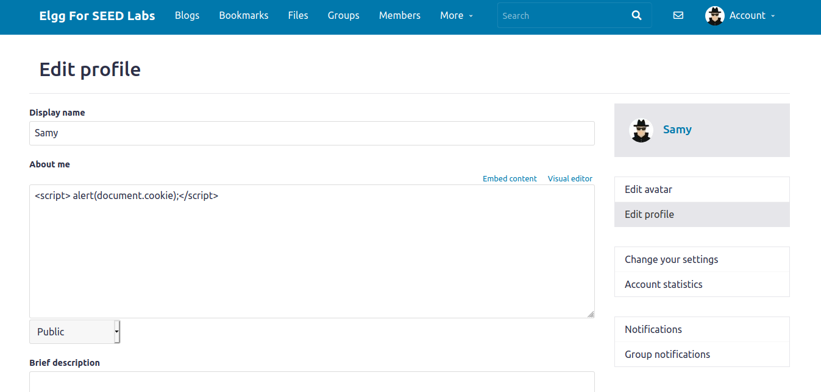

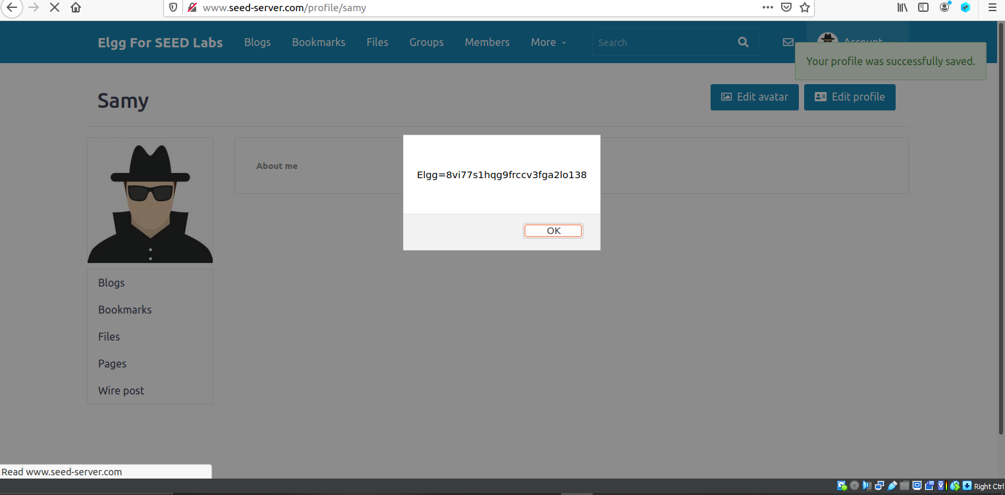

**When alice visits Samy’s profile**

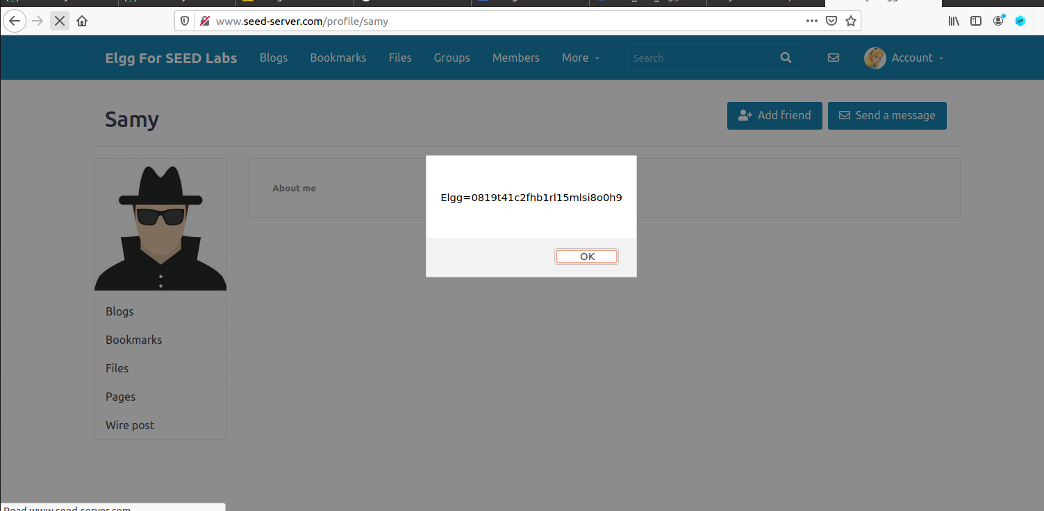

**TASK 3**

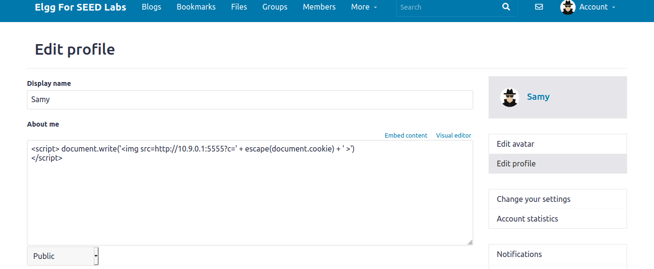

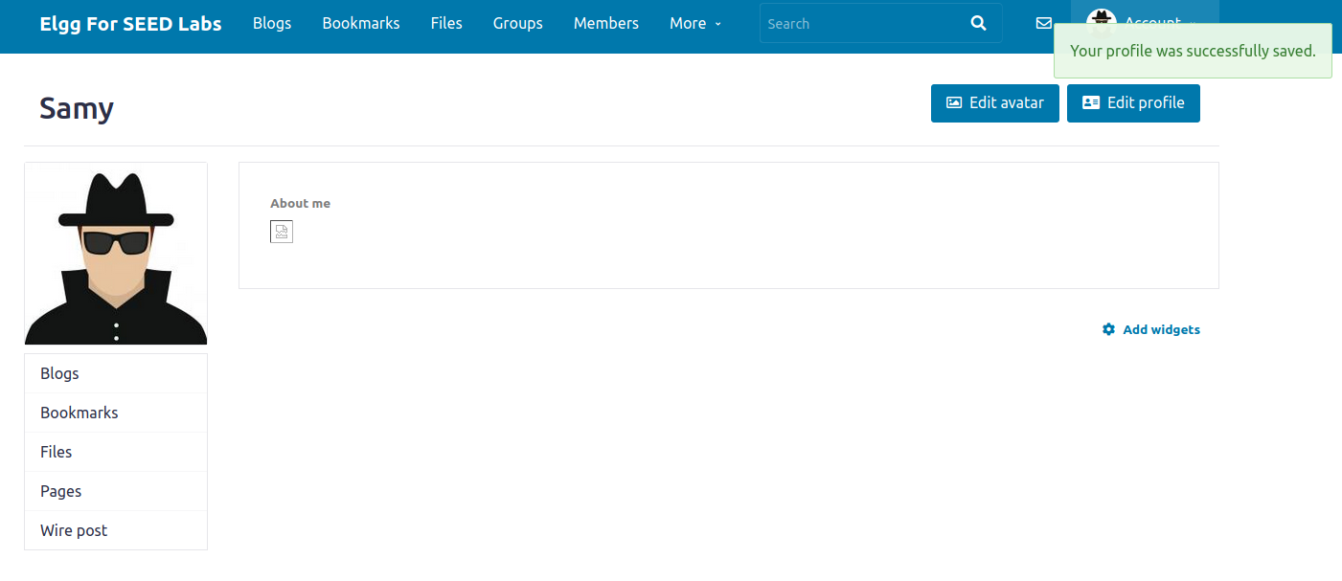

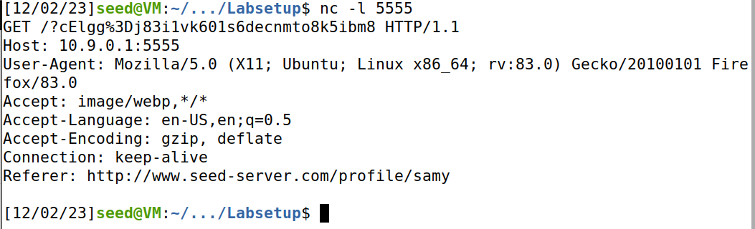

When alice checked samy's profile,

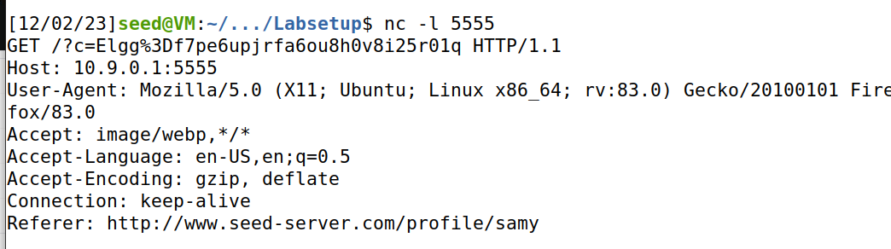

**TASK 4**

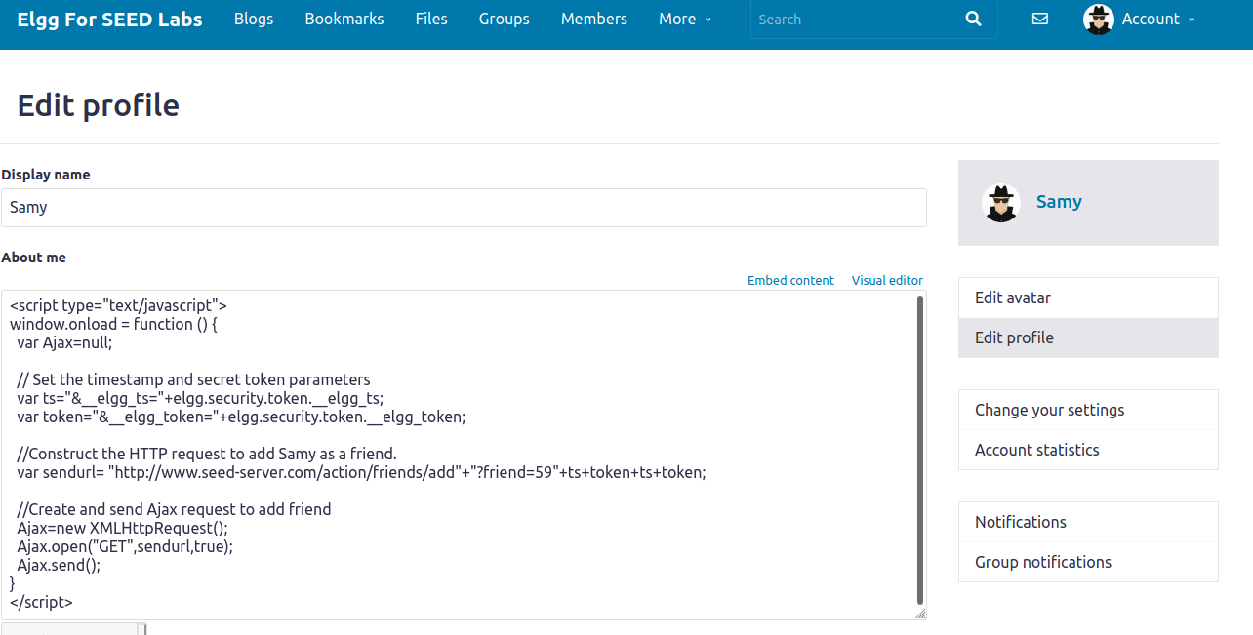

When logged in from alice’s account and visited samy’s account, then he will automatically be added to alice’s friend list

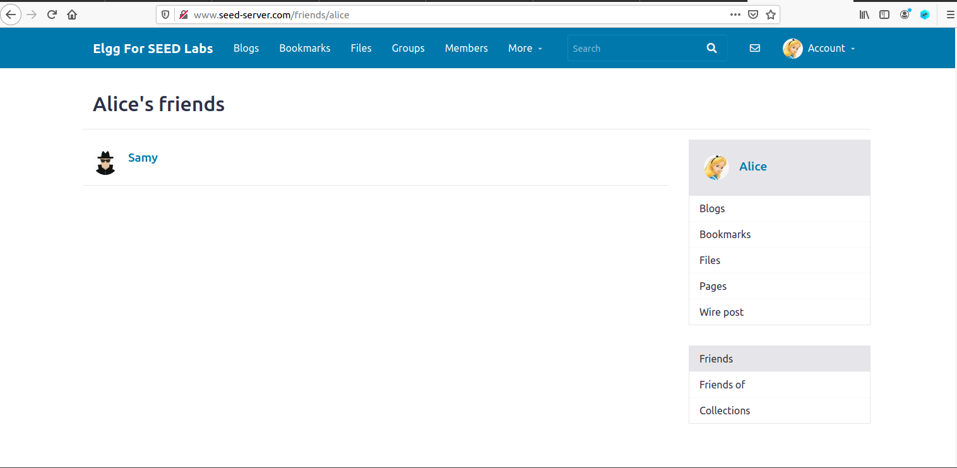

**Question 1: Explain the purpose of Lines ➀ and ➁, why are they are needed?**

Line ➀ (var ts="&__elgg_ts="+elgg.security.token.__elgg_ts;):

elgg.security.token.__elgg_ts seems to be a timestamp value related to the Elgg security token.

* The purpose of including a timestamp in the URL might be to prevent certain types of attacks, such as replay attacks. By including a timestamp, the server can verify that the request is recent and not a replay of an old request.

Line ➁ (var token="&__elgg_token="+elgg.security.token.__elgg_token;):

elgg.security.token.__elgg_token appears to be the Elgg security token itself.

* Including the security token in the URL is a common practice in web applications to ensure that the request is legitimate and comes from a trusted source. The security token helps prevent cross-site request forgery (CSRF) attacks, where an attacker tries to perform actions on behalf of an authenticated user.

When a user interacts with the web application, these parameters (__elgg_ts and __elgg_token) are likely added to the URL of the request, and the server checks them to verify the authenticity and freshness of the request. It's part of the security measures implemented in the Elgg framework to protect against certain types of web application vulnerabilities.

**Question 2: If the Elgg application only provide the Editor mode for the "About Me" field, i.e., you cannot switch to the Text mode, can you still launch a successful attack?**

* Even with only an editor mode in the "About Me" field, potential security risks include editor vulnerabilities, scripting within permitted elements, stored XSS, content spoofing, and third-party plugin vulnerabilities. Adequate input validation and security measures remain crucial for preventing attacks**.**

**TASK 5**

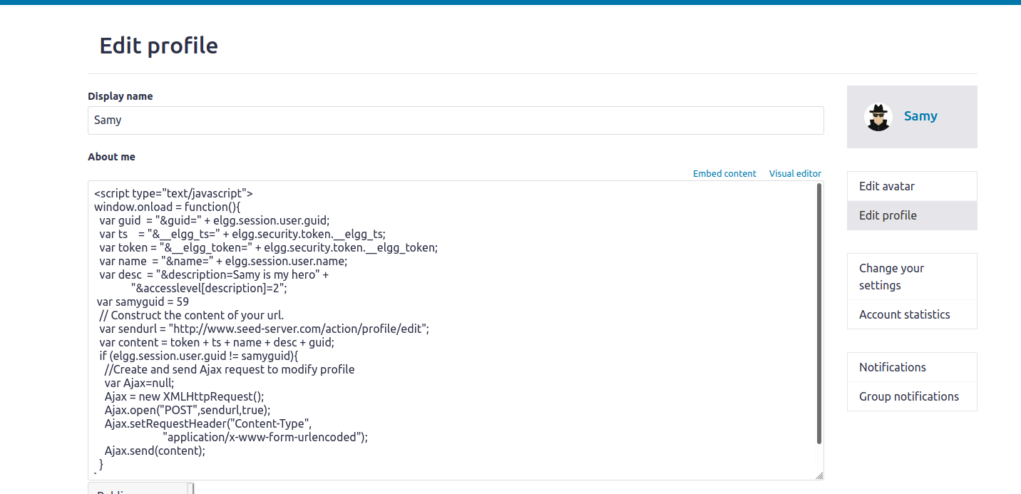

**Question Number 3: Why do we need Line ➀? Remove this line, and repeat your attack. Report and explain your observation.**

* If the GUID of the currently logged-in user is not equal to 59(that is Samy’s), then send an AJAX request to modify the user's profile.
* It means that samy can modify the profile of the user other than his own profile i.e; Alice’s profile
* elgg.session.user.guid: This represents the GUID (Globally Unique Identifier) of the currently logged-in user in the Elgg application. It's a unique identifier assigned to each user.

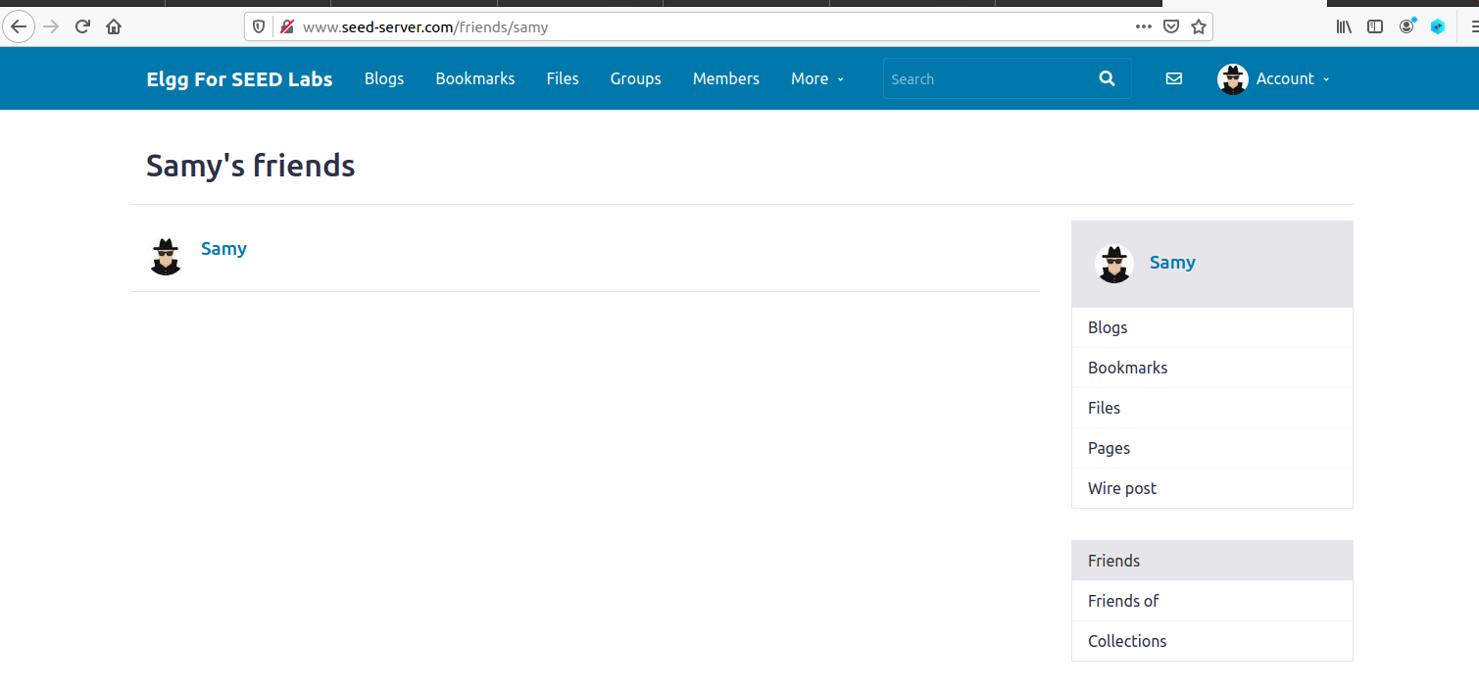

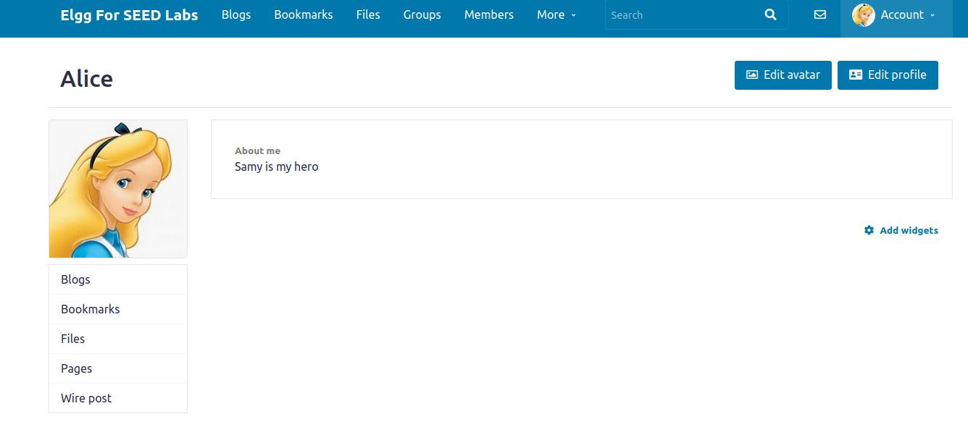

**TASK 6**

**Link approach**

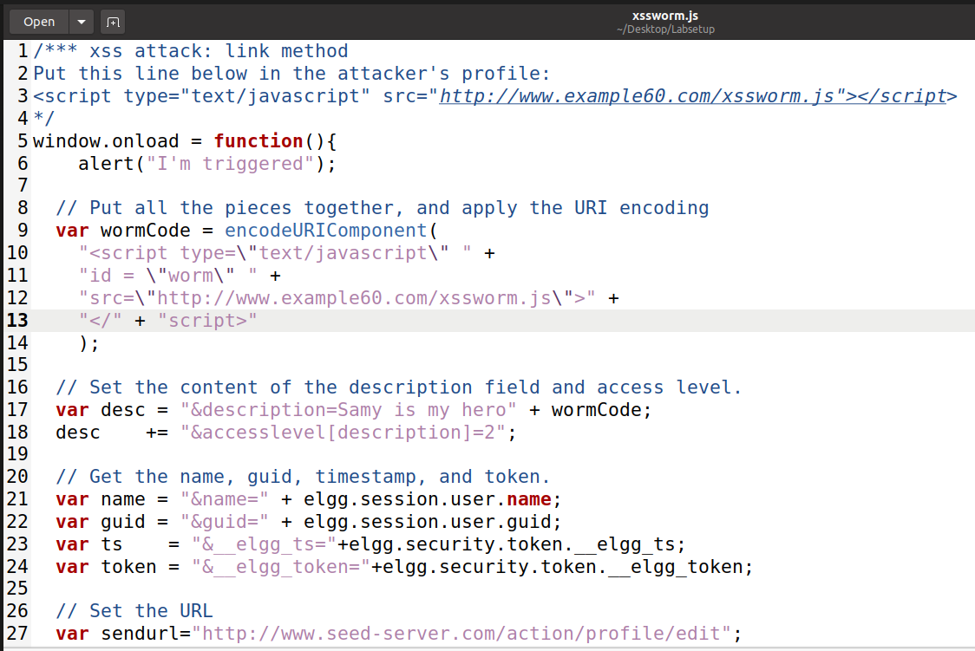

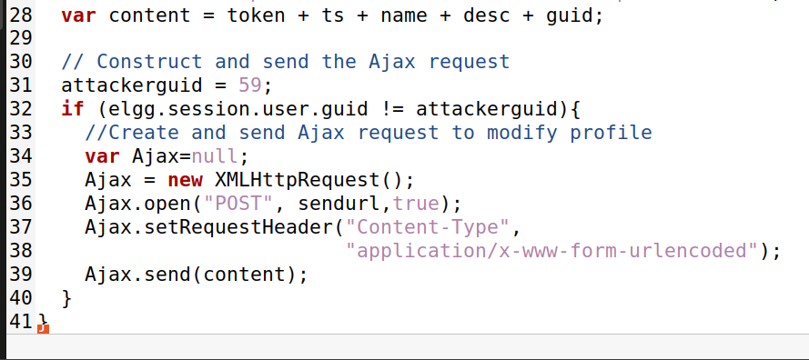

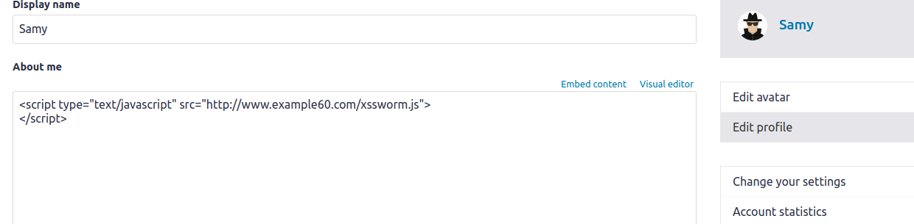

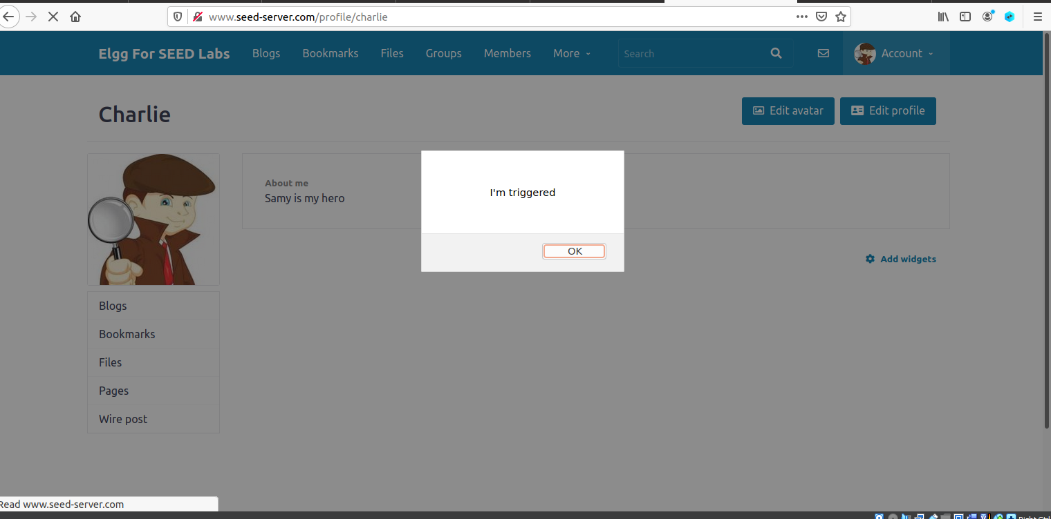 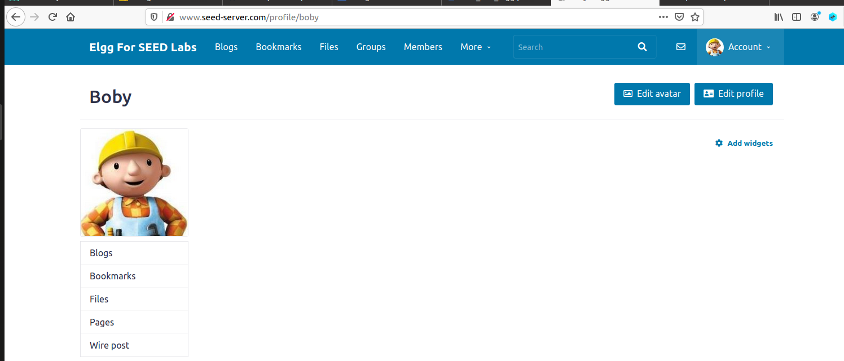

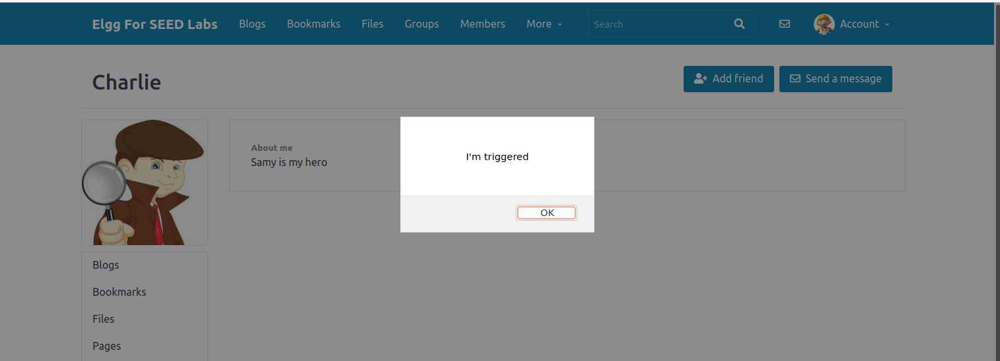

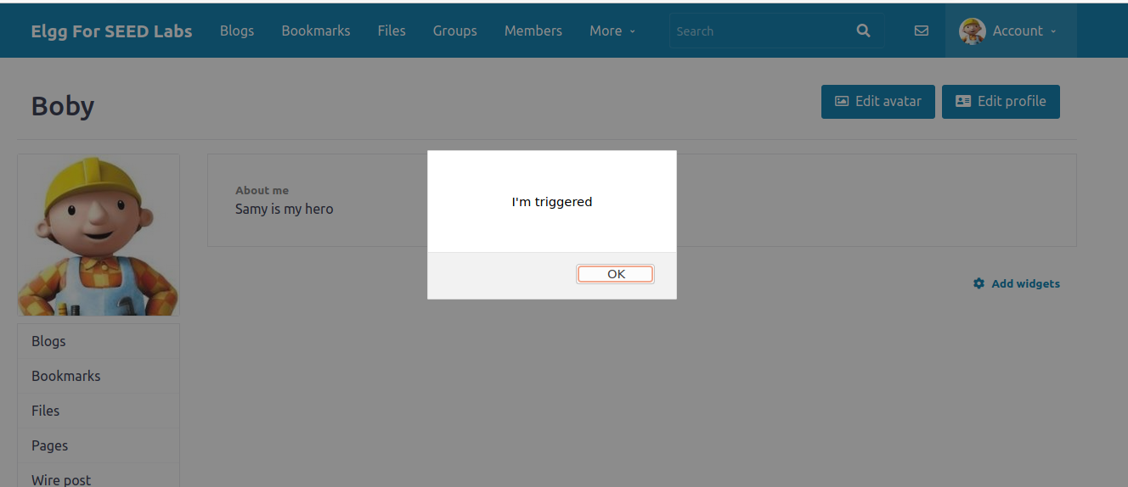

**DOM approach**

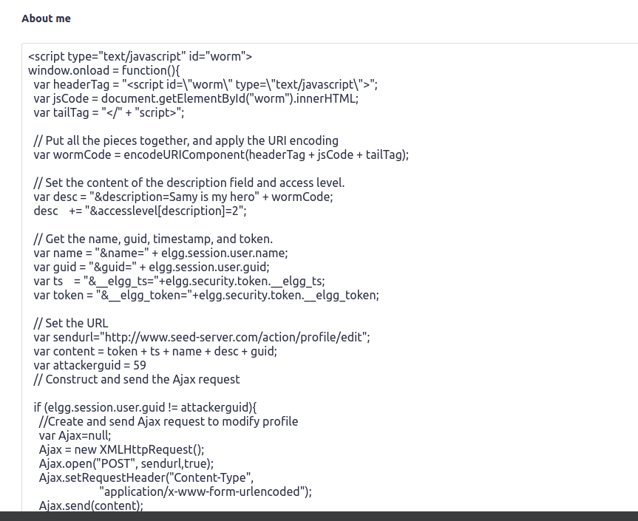

**Alice visits Samy’s profile**

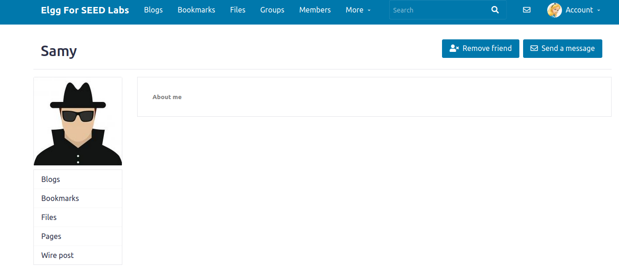

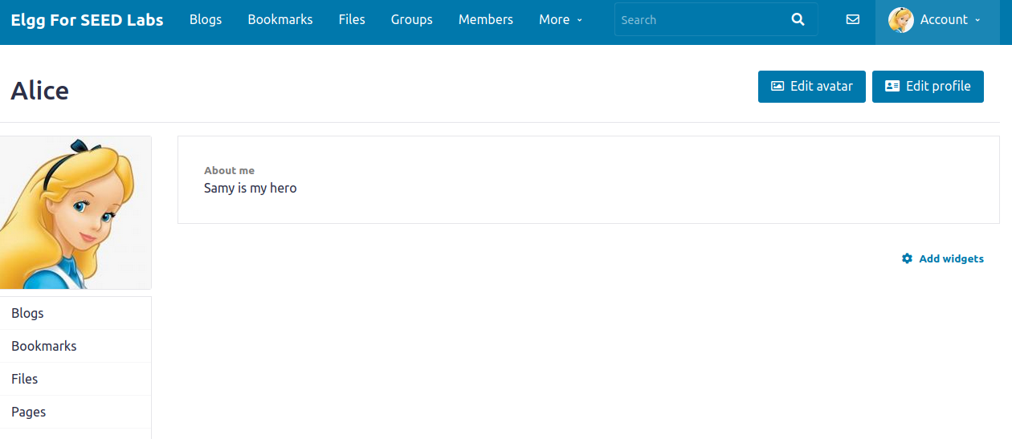

Logged into charlie’s profile, there was nothing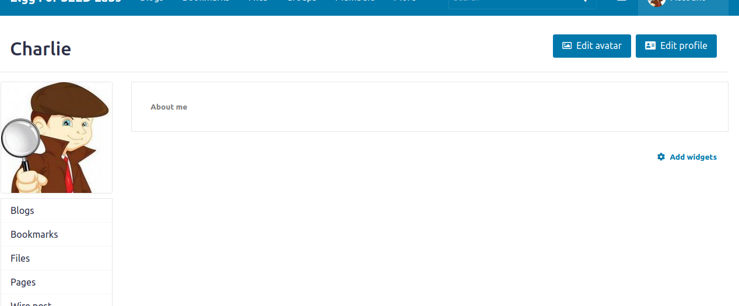

Then he visits alice’s profile

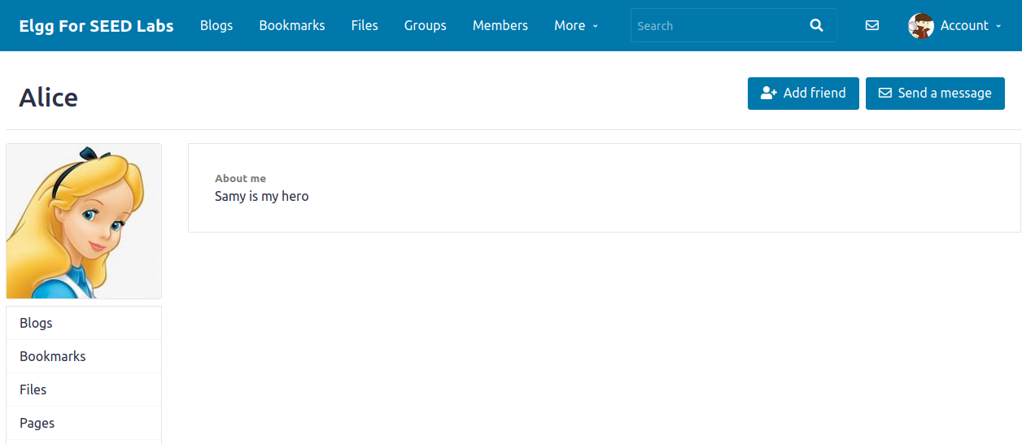

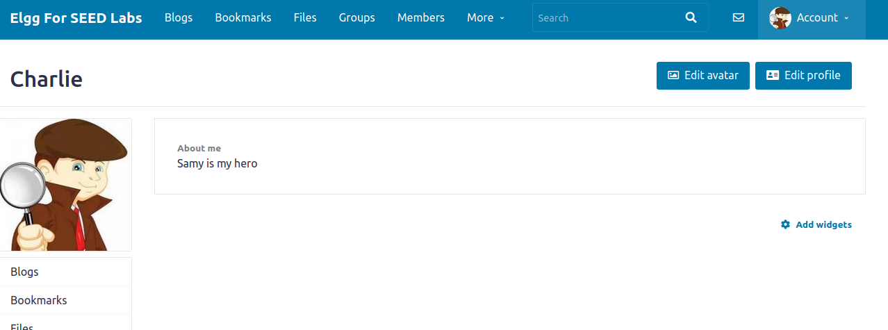

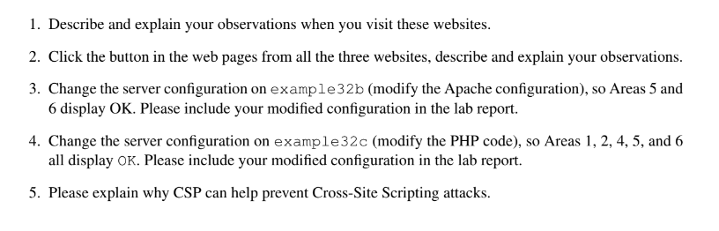

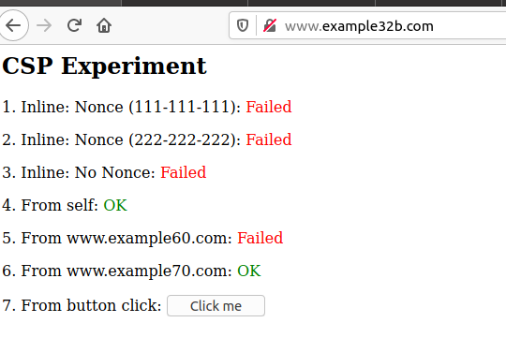

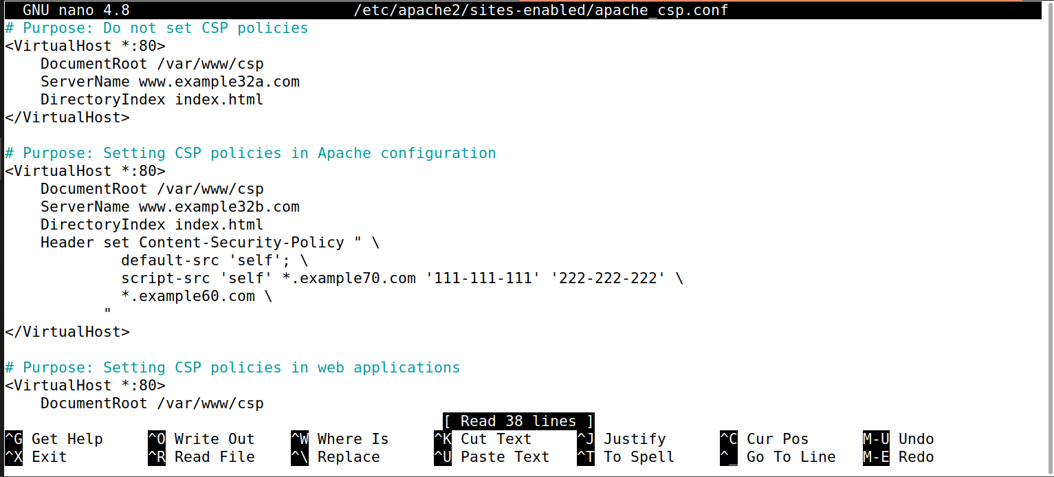

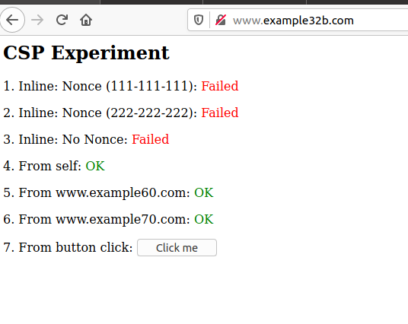

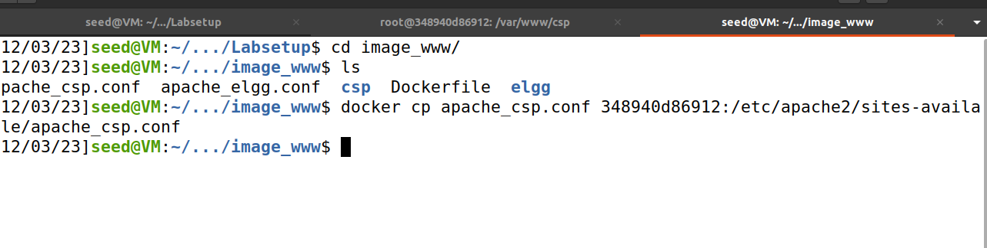

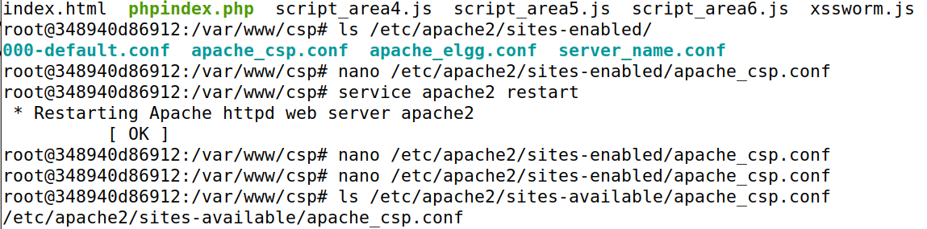 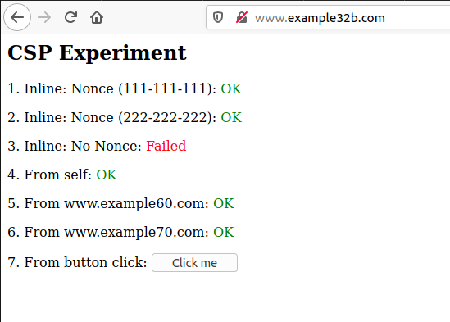

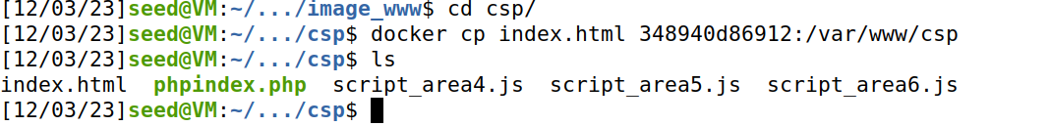

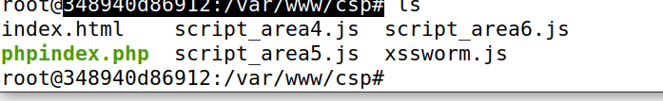

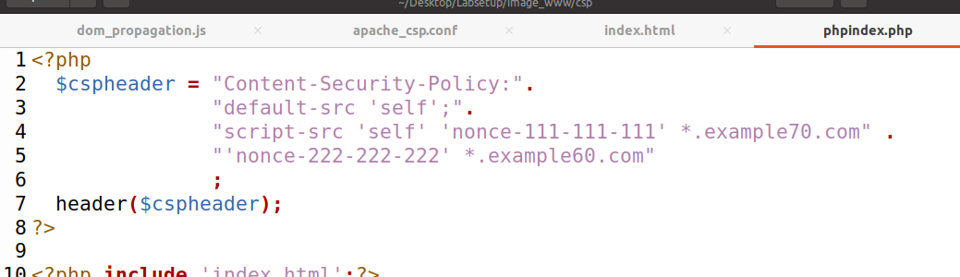

 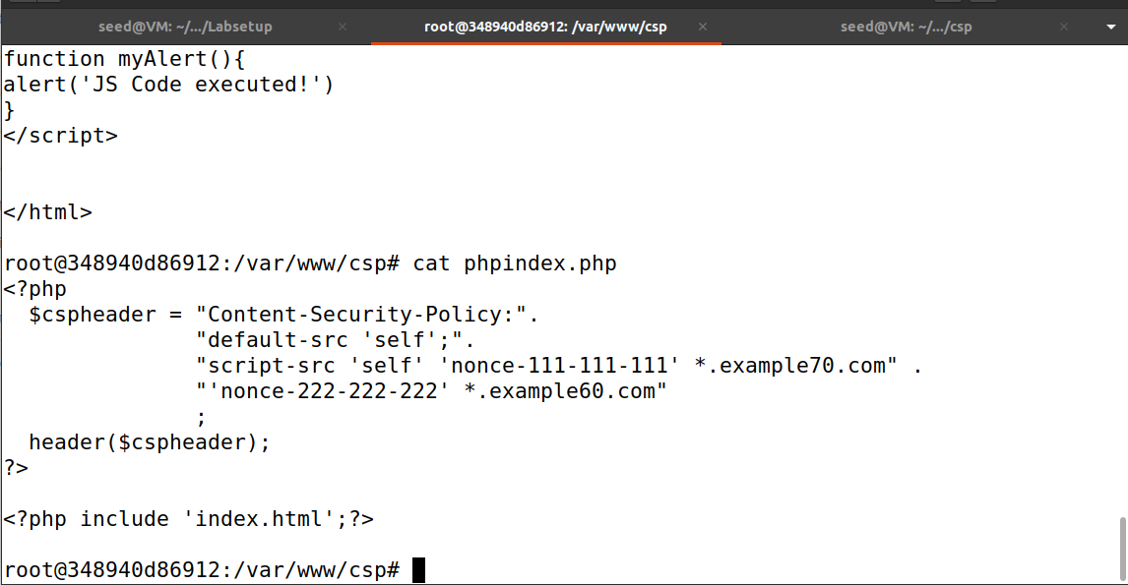 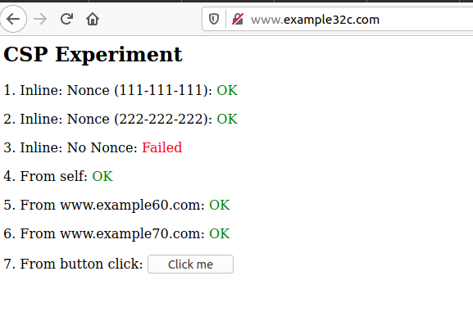

**SQL INJECTION LAB**

2.1 Container Setup and Commands:

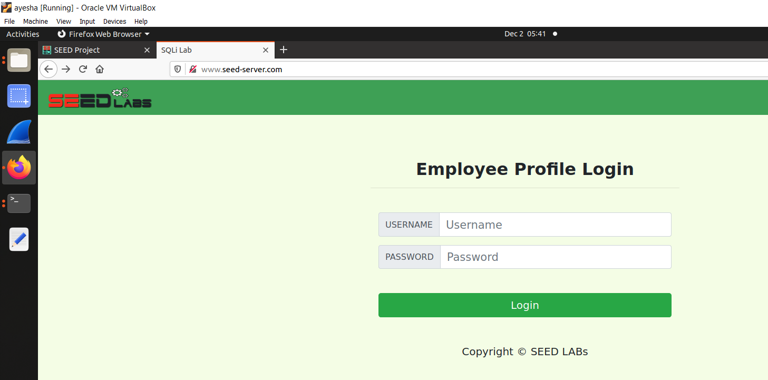

2.2 About the Web Application:

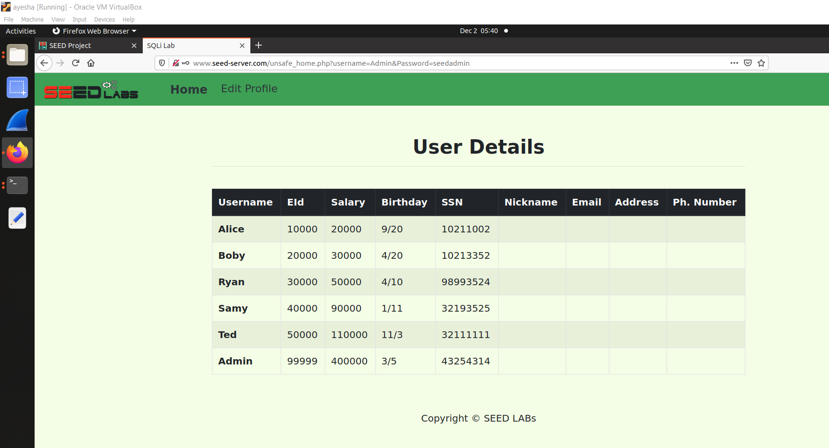

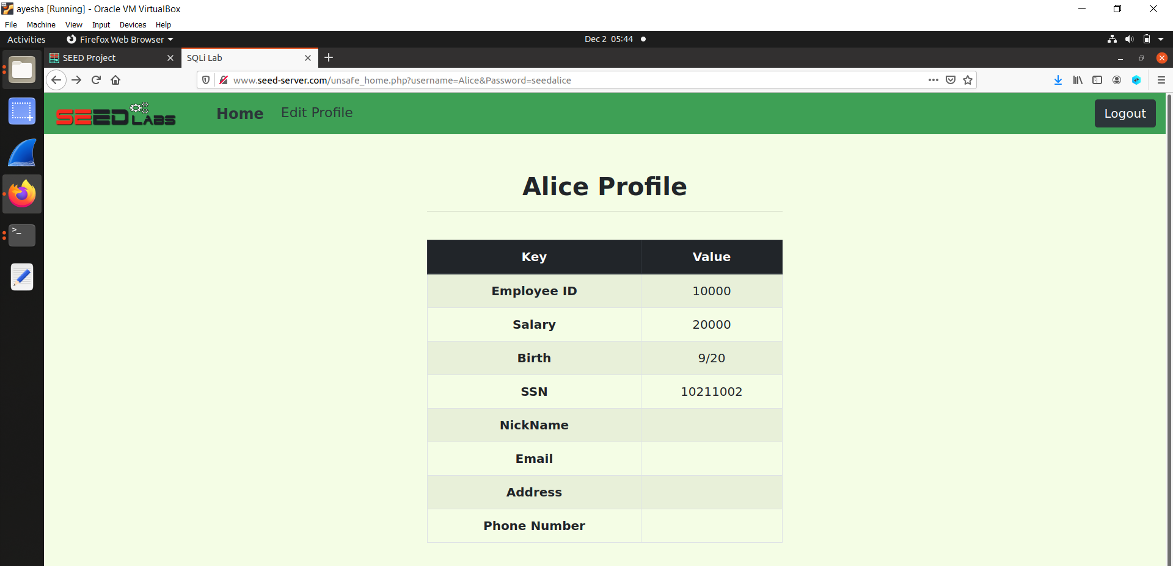

3 Lab Tasks

3.1 Task 1: Get Familiar with SQL Statements

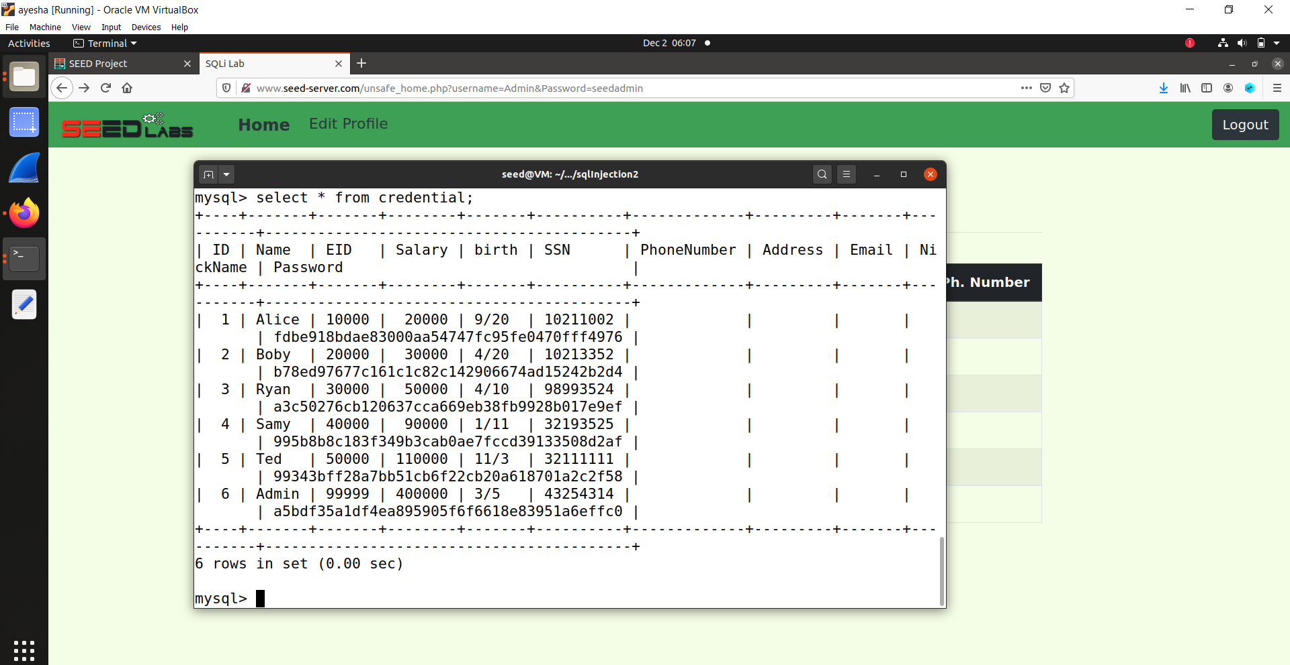

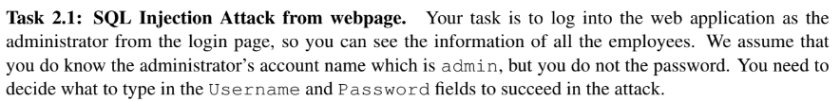

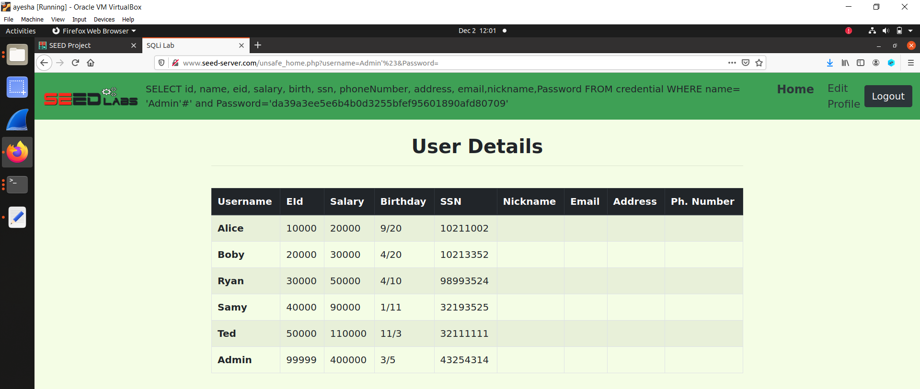

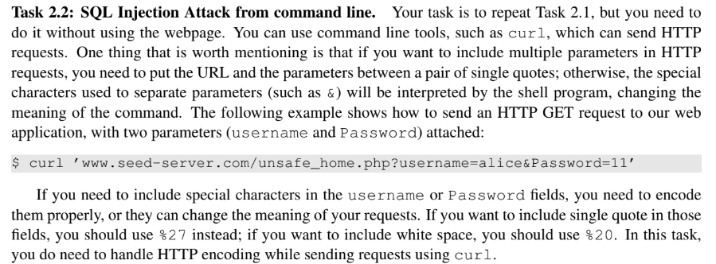

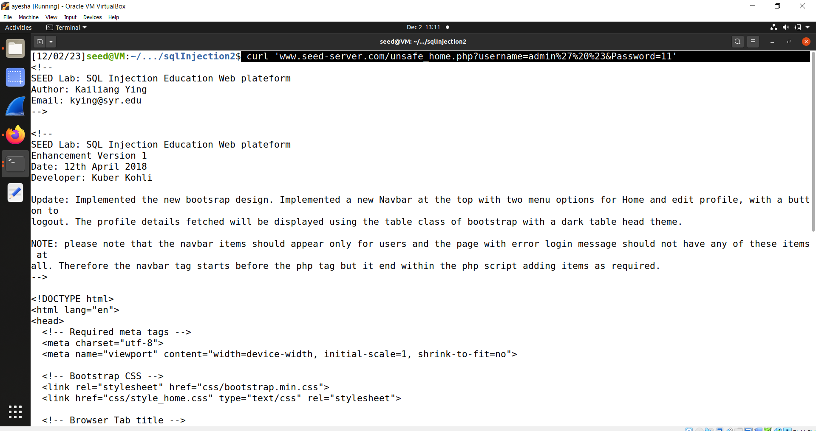

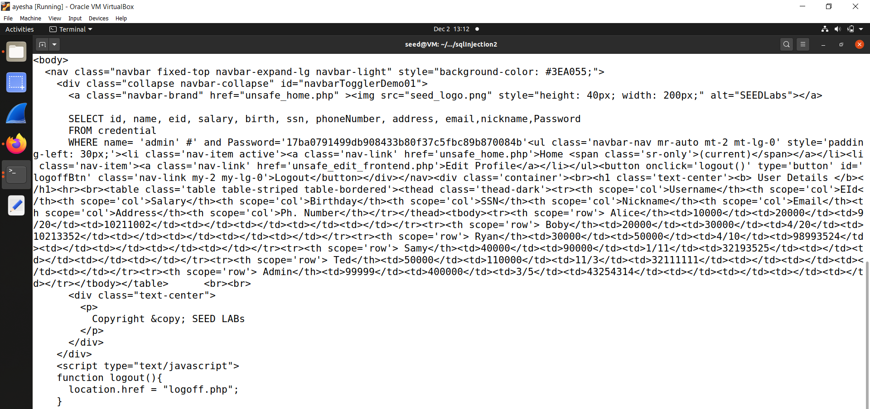

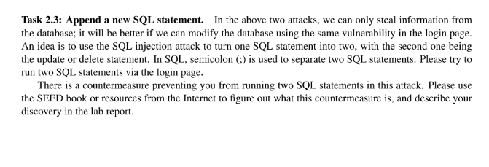

Changes in file undafe_home.php

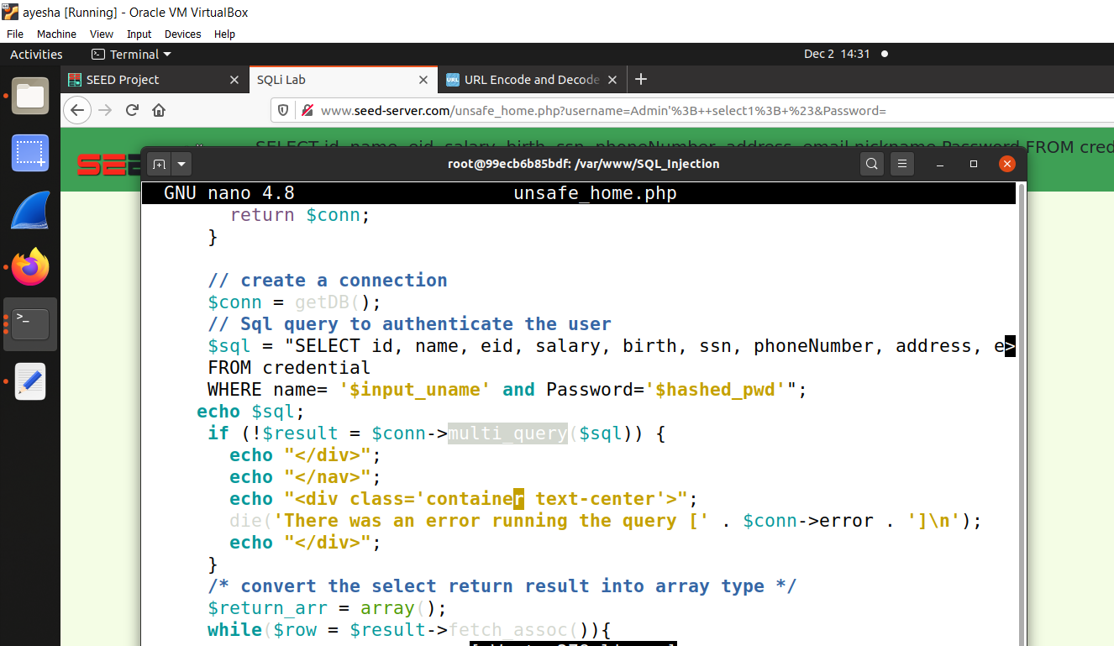

By http://www.server_seed.com

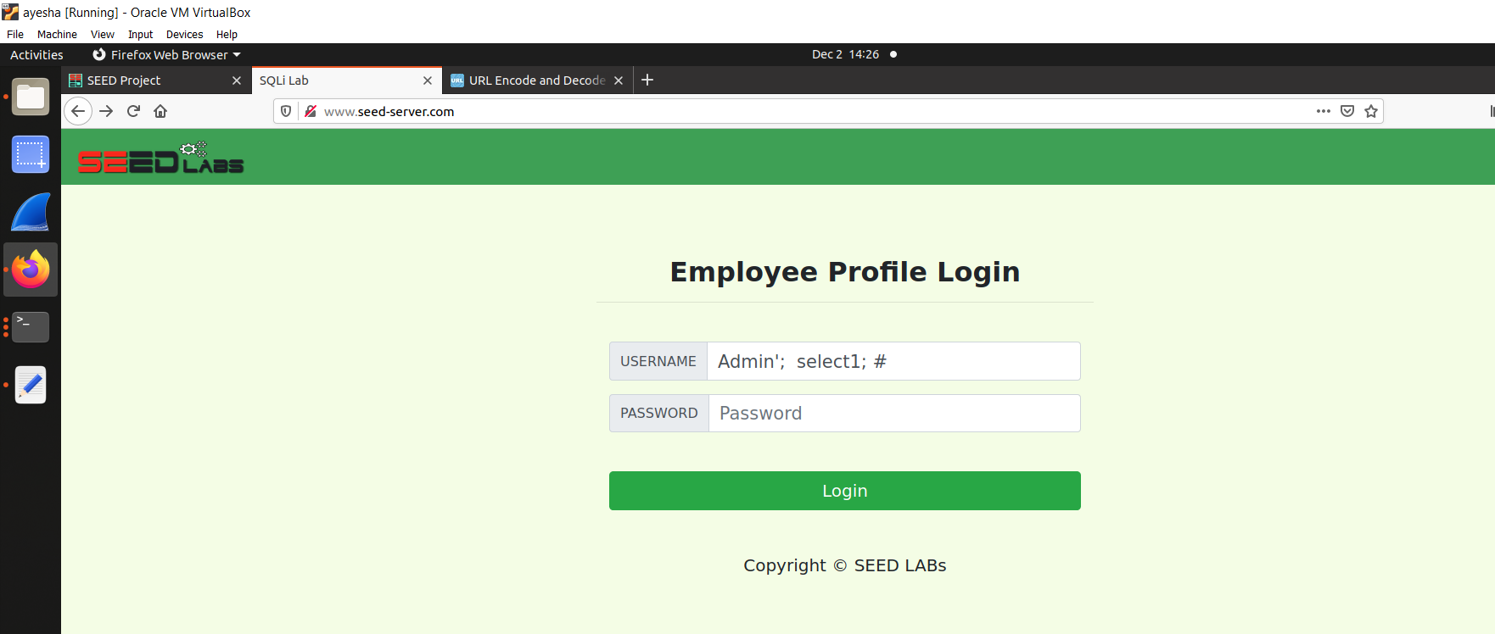

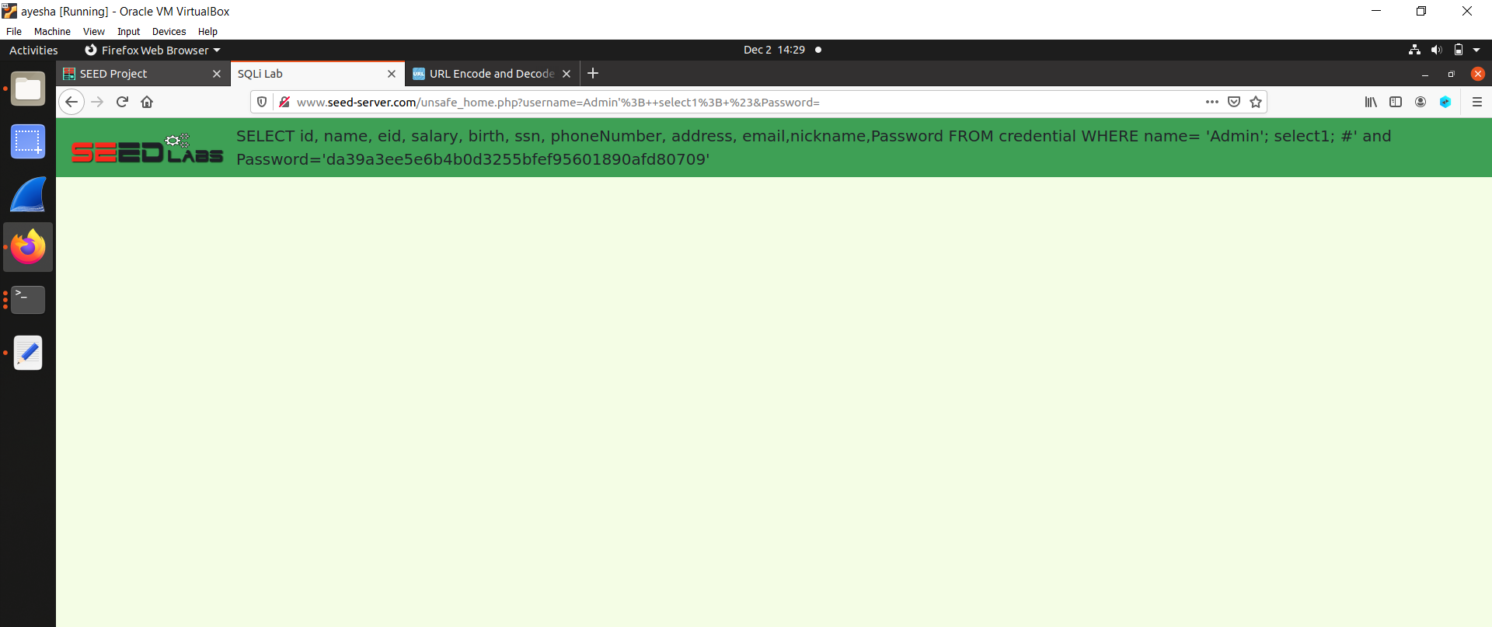

By curl command:

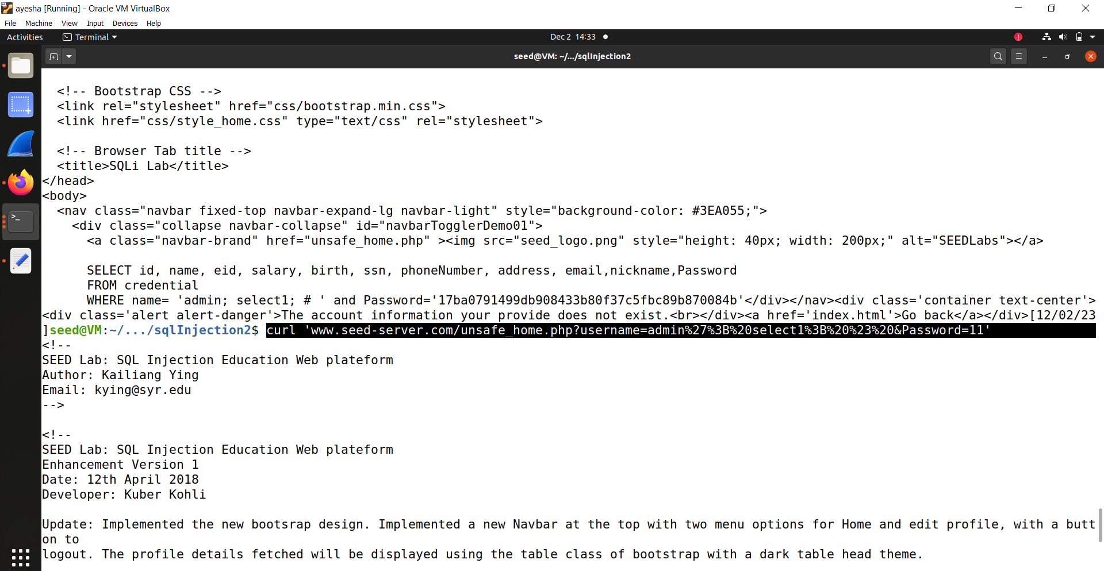

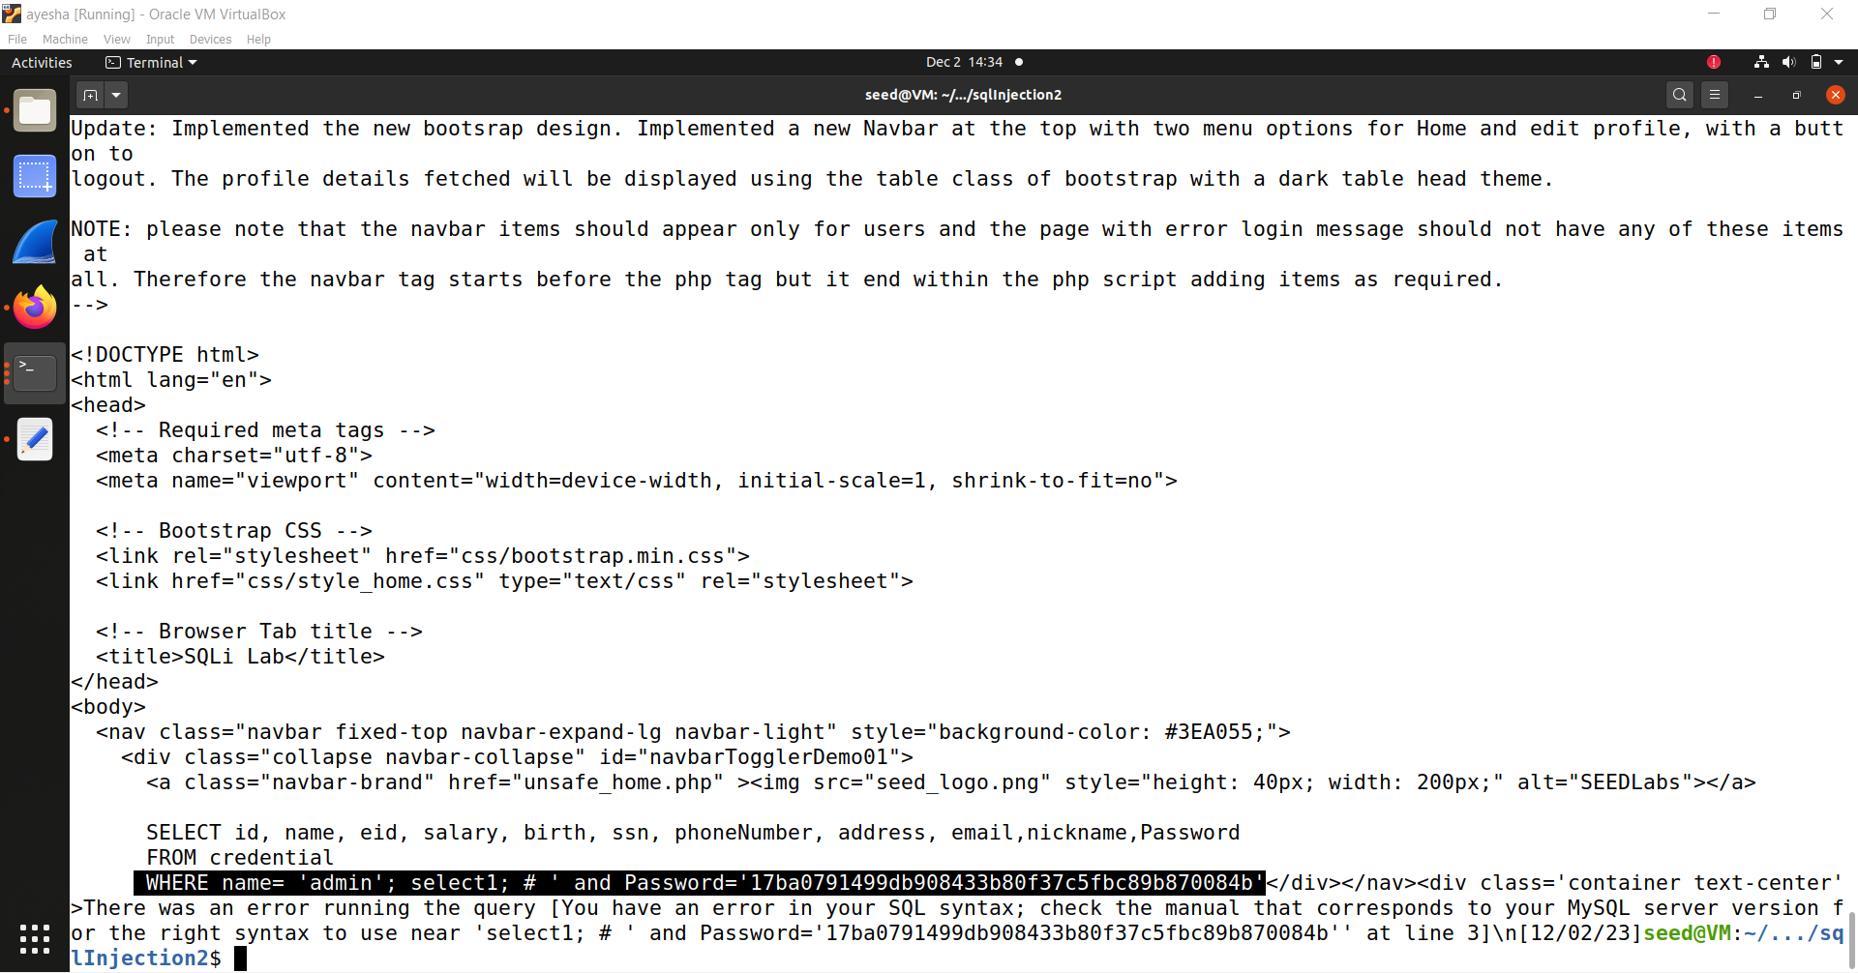

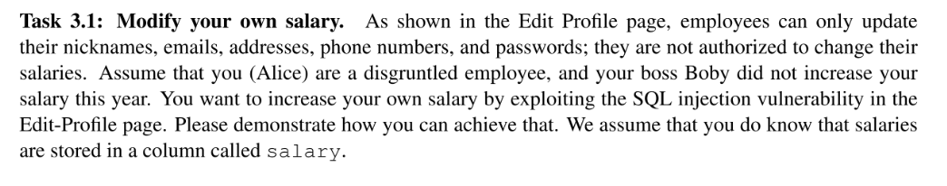

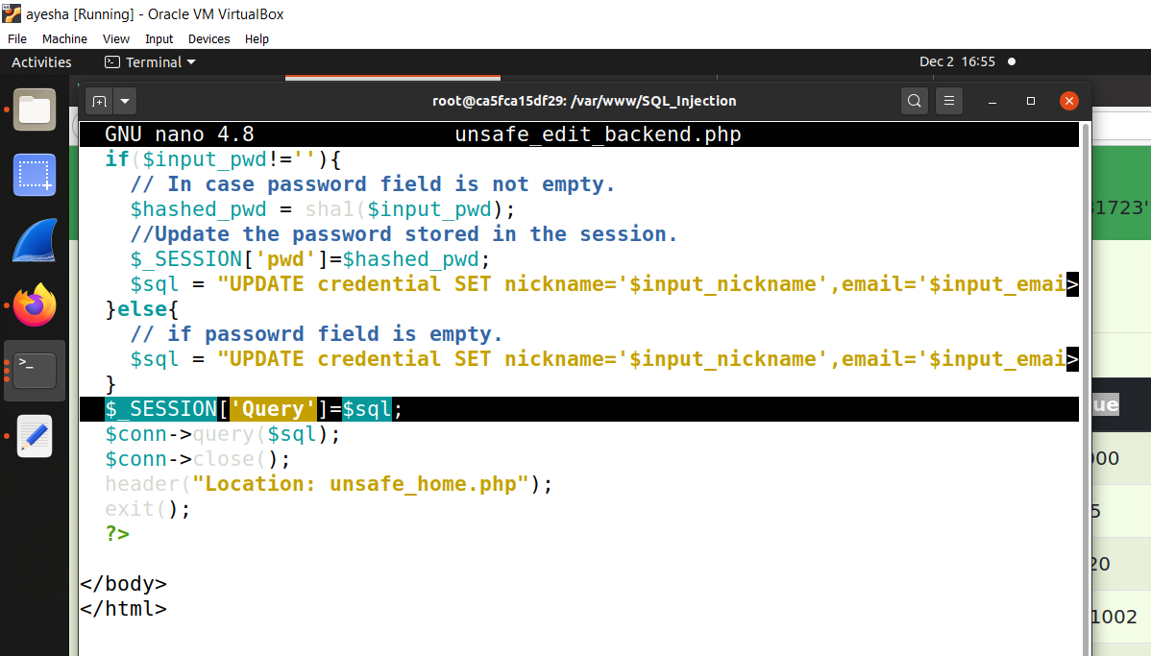

unsafe_home.php

